Software Design Document
<Smart Assistant (University Information Chatbot)>



Submitted by
<Muhammad Rizwan Gull (F22BINFT1M01030)>

Submitted to
<Dr Muhammad Asadullah>

Department of Information Technology
Faculty of Computing
The Islamia University of Bahawalpur

Summery
This document outlines the detailed design of the University Information Chatbot, a web-based virtual assistant for The Islamia University of Bahawalpur. The system is designed to automate responses to common university-related queries such as admissions, schedules, fees, exams, and campus information. The design follows an MVC architecture, uses Flask (Python) for the backend, MySQL for the database, and a rule-based NLP engine for query understanding. The interface is responsive, user-friendly, and accessible across devices. This document covers the application architecture, data model schema, and user interface design in detail.

Table of Content
1. Application Architecture
1.1. System Overview
1.2. MVC Architecture
1.3. Component Details
1.4. Sequence Diagram
1.5. Coding Conventions

2. Data Model Schema
2.1. Database Schema
2.2. Entity Descriptions
2.3. ER Diagram

3. User Interface
3.1. Design Philosophy
3.2. Screen List & Descriptions
3.3. Controls & Input Constraints

- Application Architecture
1.1. System Overview

The chatbot is a web-based application that can be integrated into the university website. It uses a rule-based NLP engine to interpret user queries and fetch answers from a structured knowledge base. The system is designed to be modular, scalable, and maintainabl.

1.2. MVC Architecture

The system follows the Model-View-Controller (MVC) pattern:

- Model: Manages data logic and database interactions.
- View: Represents the UI (HTML/CSS/JS).
- Controller: Handles user requests, processes logic, and returns responses.

1.3. Component Details

Models:
- User Model: Stores admin credentials.
- FAQ Model: Stores predefined Q&A pairs.
- ChatLog Model: Logs user interactions.
- Category Model: Organizes FAQs into topics (Admissions, Fees, Exams, etc.).

Views:
- Login Page: Admin authentication.
- Chat Interface: Main user chat window.
- Admin Dashboard: Manage FAQs and view logs.

Controllers
- AuthController: Handles admin login/logout.
- ChatController: Processes user messages, calls NLP engine, returns answers.
-AdminController: Allows CRUD operations on FAQs and categories.

External Components:
- NLP Engine (Rule-based): Uses keyword matching and intent classification.
- Flask Server: Lightweight Python web server.
- MySQL Database: Stores all structured data.

1.4. Sequence diagram
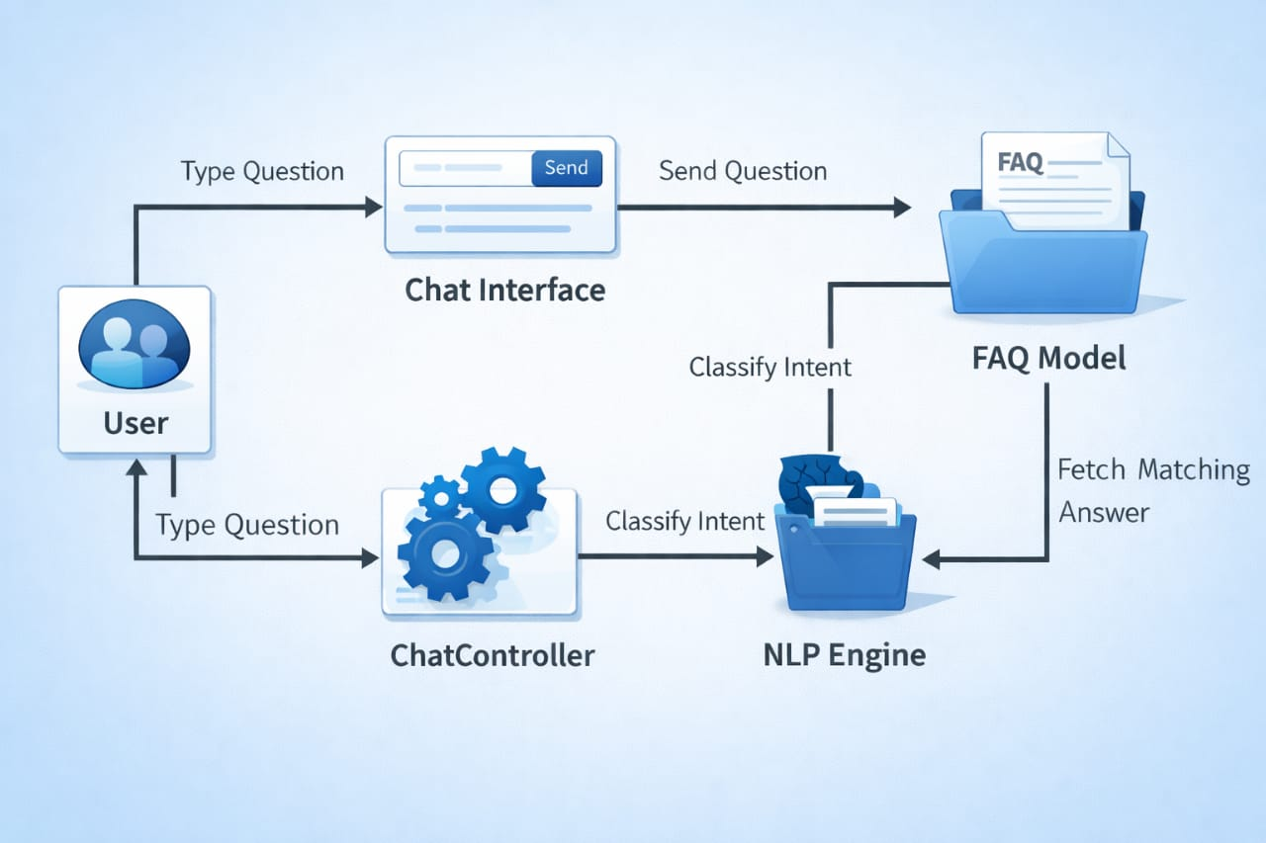

User -> Chat Interface: Type Question
Chat Interface -> ChatController: Send Question
ChatController -> NLP Engine: Classify Intent
NLP Engine -> FAQ Model: Fetch Matching Answer
FAQ Model -> ChatController: Return Answer
ChatController -> Chat Interface: Display Response
Chat Interface -> User: Show Answer

1.5. Coding Conventions

- Backend: Python (PEP 8 standards), Flask framework.
- Frontend: HTML5, CSS3, Vanilla JavaScript (ES6).
- Database: SQL queries parameterized to prevent injection.
- File Structure: Modular separation (models/, views/, controllers/, static/, templates/).

- Data Model Schema
2.1. Database Schema

Tables:

1. users
- id (INT, PK)
- name (VARCHAR)
- email (VARCHAR, UNIQUE)
- password (VARCHAR)
- role (ENUM: 'admin', 'user')

2. categories
- id (INT, PK)
- name (VARCHAR)
- description (TEXT)

3. faqs
- id (INT, PK)
- question (TEXT)
- answer (TEXT)
- category_id (INT, FK)
- keywords (TEXT)

4. chat_logs
- id (INT, PK)
- user_ip (VARCHAR)
- question (TEXT)
- answer (TEXT)
- timestamp (DATETIME)

2.2. Entity Descriptions

- users: Only admins can log in to manage FAQs.
- categories: Groups FAQs (e.g., Admissions, Fees, Exams).
- faqs: Contains predefined questions and answers with associated keywords for matching.
- chat_logs: Stores all user interactions for analytics and improvement.

2.3. ER Diagram
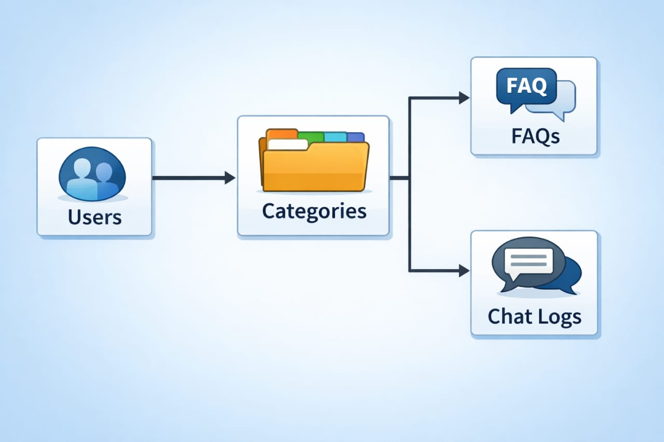

- User Interface
3.1. Design Philosophy

- Color Scheme: University-branded colors (green, white, gold).
- Font: Sans-serif (Arial, Segoe UI) for readability.
- Responsive Design: Works on mobile, tablet, and desktop.
- Accessibility: High contrast, keyboard navigable.

3.2. Screen List & Descriptions

1. Login Page
- Purpose: Admin authentication.
- Controls: Email input, password input, login button.
- Validation: Email format, password length ≥ 8 characters.

2. Chat Interface (Main Page)
- Purpose: User interaction with chatbot.
- Controls: Text input box, send button, chat history panel.
- Features: Typing indicator, quick-reply buttons for common topics.

3. Admin Dashboard
- Purpose: Manage FAQs and view logs.
- Controls: Add/edit/delete FAQs, filter by category, export logs.
- Validation: Duplicate question prevention, required fields.

3.3. Controls & Input Constraints

- Text Input: Max 500 characters per message.
- Buttons: Hover effects, clear CTA labels.
- Dropdowns: Predefined categories for FAQ management.
- Error Messages: User-friendly prompts for invalid inputs.

